What is Docker in simple terms?
https://www.youtube.com/watch?v=qN1CzLdCq5g

Docker vs Virtual Machine (VM)?
https://www.youtube.com/watch?v=5GanJdbHlAA
“A virtual machine runs a full operating system with its own kernel, making it heavier, while Docker containers share the host OS kernel and only package the application and dependencies, making them lightweight and faster.”

Virtual Machine (VM):
- Runs full operating system (OS)
- Includes OS Kernel + Applications + dependencies
- Uses Hypervisor to manage VMs
- Heavyweight (large size)
- Slower startup

Docker (Containers):
- Runs only application + dependencies
- Shares host OS kernel
- Lightweight (small size)
- Faster startup

Key Differences:
- VM = Full OS → heavy
- Docker = Uses host OS → lightweight
- VM = More isolation
- Docker = Faster and efficient

Example:
- VM: Runs separate Windows/Linux OS inside machine
- Docker: Runs multiple apps using same OS kernel

Docker Image vs Container simple:
https://www.youtube.com/watch?v=bSe3qawNQEY

“A Docker image is a read-only template that contains the application and its dependencies, while a container is a running instance of that image. One image can be used to create multiple containers.”

Docker Image:
- Read-only template
- Contains application code + dependencies + libraries + runtime (e.g., JDK)
- Used to create containers

Docker Container:
- Running instance of a Docker Image
- Executes the application
- Uses dependencies packaged inside the image
- Isolated from host system (no need to install dependencies locally)

Key Points:
- One image → multiple containers
- Containers are lightweight and fast
- Different containers can run different environments simultaneously

Example:
- One container runs app with JDK 8
- Another container runs app with JDK 21
- Both run on same system without conflict

Docker Port Mapping:
https://www.youtube.com/watch?v=peMxZW3M24g

What is a port?
A port is a logical, numbered endpoint in a computer that allows different applications or services to communicate over a network.
It helps the operating system route incoming and outgoing data to the correct application.

🧠 Stronger Analogy (slightly upgraded)
- IP address = Building address
- Port number = Apartment number
- Application = Person living inside
So, when data arrives:
👉 It first reaches the building (IP)
👉 Then goes to the correct apartment (port)
👉 Finally handled by the person (application)

💡 Example
- Web server → Port 80 (HTTP) or 443 (HTTPS)
- Database (MySQL) → Port 3306

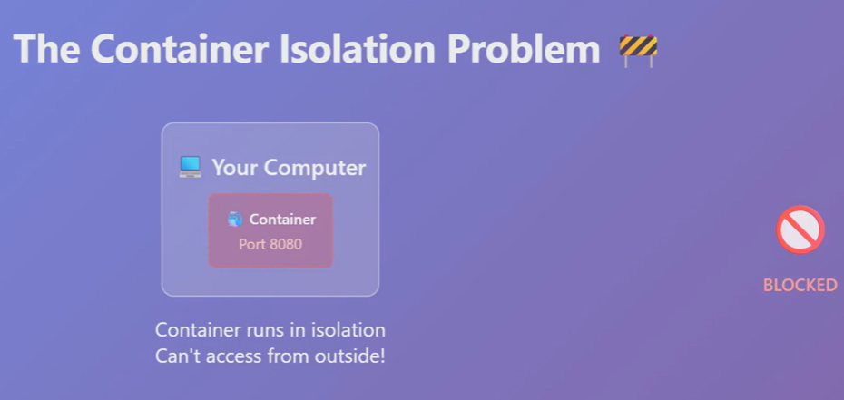
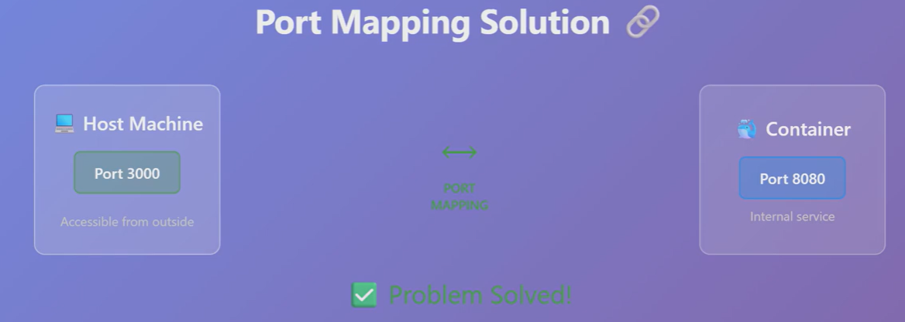

A Docker container may run an application on a specific internal port (e.g., 8080).
To access this application from the host machine, Docker provides port mapping, which maps a host port (e.g., 3000) to the container’s port (8080). This allows external requests to reach the application inside the container.
🧠 Simple analogy
- Container = Flat inside a building
- App inside container = Person inside flat (listening on 8080)
- Host port (3000) = Reception desk
👉 You talk to reception (3000)
👉 Reception forwards to the correct flat (8080)
Docker Port Mapping Syntax:
docker run -p <host_port>:<container_port> <image_name>
Example:
docker run -p 3000:8080 my-app
Explanation:
docker run: Creates and starts a container from an image
-p: Specifies port mapping
3000:8080 → Maps host port 3000 to container port 8080
my-app: Name of the Docker image

Example with Nginx:
docker run -p 3000:80 nginx
Now, we can access the application at:
http://localhost:3000

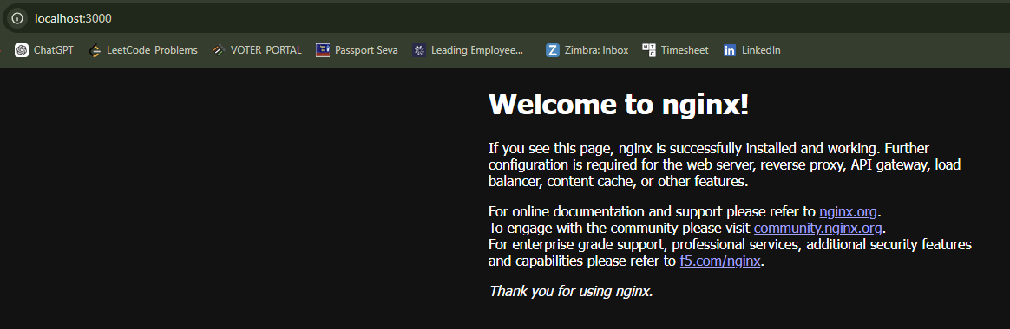

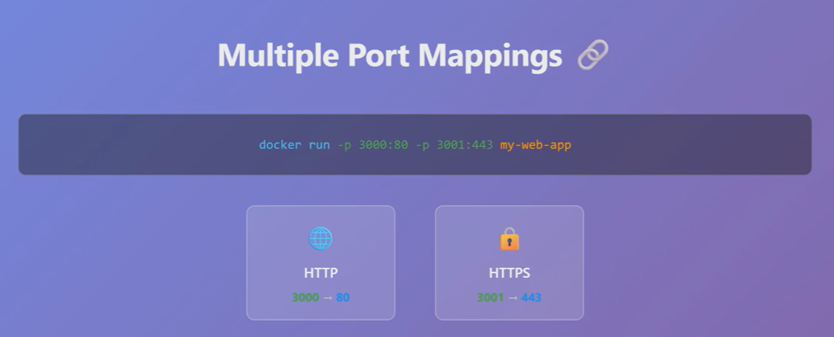

docker run -p 3000:80 -p 3001:443 my-web-app
Explanation:
docker run: Creates and starts a container from the my-web-app image
-p 3000:80 → Maps host port 3000 to container port 80 (HTTP)
-p 3001:443 → Maps host port 3001 to container port 443 (commonly HTTPS, if configured)
This allows:
- Access HTTP service via http://localhost:3000
- Access HTTPS service via https://localhost:3001 (if HTTPS is properly set up inside container)
So, Port mapping bridges container isolation and makes containerized services accessible from the host.
We can map multiple ports to expose different services of the same container.

